Department of Human Ecology

UC DAVIS

Department of Human Ecology

INJURY AND ILLNESS PREVENTION PROGRAM

This Injury and Illness Prevention Program has been prepared by the University of California,

Department of Human Ecology, in accordance with University Policy (UCD Policy

& Procedure Manual Section 290-15: Safety Management Program) and California Code of

Regulations Title 8, Section 3203 (8 CCR, Section 3203).

UC DAVIS

Department of Human Ecology

INJURY AND ILLNESS PREVENTION PROGRAM

TABLE OF CONTENTS

Preface Department Information

- Authorities and Responsible Parties

- System of Communications

- System for Assuring Employee Compliance with Safe Work Practices

- Hazard Identification, Evaluation, and Inspection

- Accident Investigation

- Hazard Correction

- Health and Safety Training

- Recordkeeping and Documentation

- Resources

APPENDICES

- Hazard Alert/Correction Form

- Worksite Inspection Forms

- Job Safety Analyses

- Injury and Illness Investigation Form

- Safety Training Attendance Record
Department Information

Department Name: Department of Human Ecology

Department Chair: William Lacy

Address: 2321 Hart Hall, UCD Davis Campus

Telephone Number: 530-752-6964

Buildings Occupied by Department

- Building: Hart Hall

Unit(s): Human Development and Family Studies; Community and Regional Development; Cluster Five Business Unit

Contact: Ellen Barnes; William Lacy; Zhe Chen, Jonathan London, Cynthia Crestmore
Phone: 530-752-6370, 530- 752-6964, 530-754-6750, 530-219-9082, 530-752-5236

- Building: Hunt Hall

Unit(s): Landscape Architecture and Environmental Design; Cluster Five Business CAO

Contact: Meaghan Lidd; Ellen Barnes; Patsy Owens
Phone: 530-752-3907; 541-218-7055; 530-752-6437

- Building: Center for Child and Family Studies

Unit(s): Early Childhood Lab School; Human Development and Family Studies

Contact: Molly Logan-Jones; Ellen Barnes; Janet Thompson; Beth Ober
Phone: 530-752-2888; 541-218-7055; 530-754-4000; 530-752-6934/530-304-7283

- Building: Sprocket Building

Unit(s): Human Development and Family Studies

Contact: Ellen Barnes; Beth Ober, Cynthia Crestmore
Phone: 530-752-6370, 530-752-6934, 530-752-5236

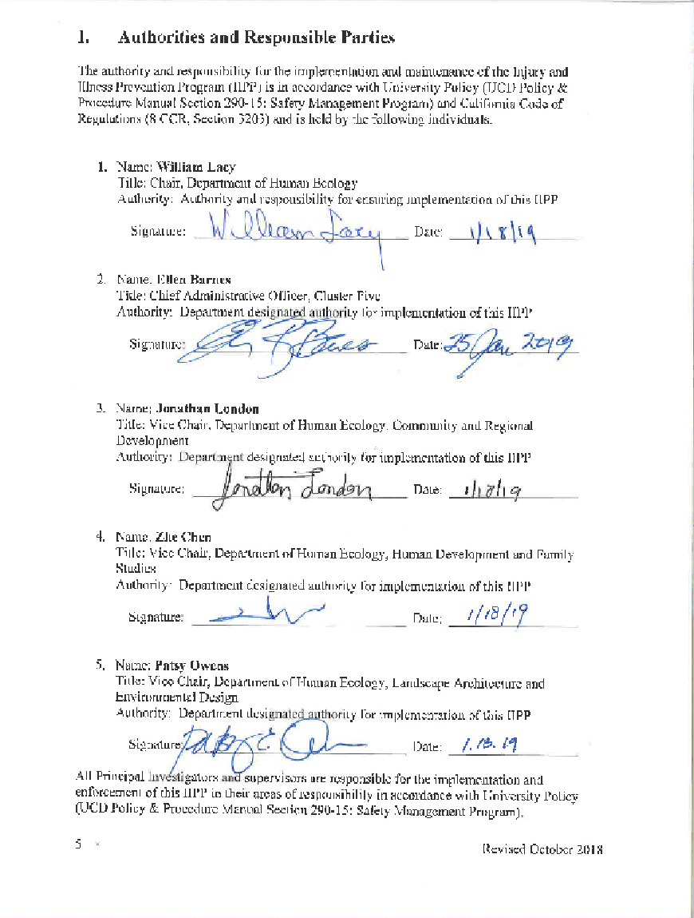
Annual Review Documentation

Responsible/Designated Authority |  | Date

II. System of Communications

- Effective communications with Department of Human Ecology employees have been established using the following methods:

☒ Standard Operating Procedures Manual
☒ Material Safety Data Sheets
☐ Monthly departmental operations meetings
☐ Internal media (department intranet)
☒ EH&S Safety Nets
☐ Training videos
☐ Safety Newsletter
☒ Handouts
☒ Building Evacuation Plan
☒ E-mail
☒ Posters and warning labels
☒ Job Safety Analysis – Initial Hire
☐ Job Safety Analysis – Annual Review
☐ Other (list):

- Employees are encouraged to report any potential health and safety hazard that may exist in the workplace. Hazard Alert/Correction Forms (Appendix A) are available to employees for this purpose. Forms are to be placed in the Safety Coordinator’s departmental mail box. Employees have the option to remain anonymous when making a report.

- Employees have been advised of adherence to safe work practices and the proper use of required personal protective equipment. Conformance will be reinforced by discipline for non-compliance in accordance with University policy (UC Davis Personnel Policies for Staff Members- Section 62, Corrective Action).

III. System for Assuring Employee Compliance with Safe Work Practices

Employees have been advised of adherence to safe work practices and the proper use of required personal protective equipment. Conformance will be reinforced by discipline for non-compliance in accordance with University policy (UC Davis Personnel Policies for Staff Members- Section 62, Corrective Action).

The following methods are used to reinforce conformance with this program:
- Distribution of Policies

- Training Programs

- Safety Performance Evaluations

Performance evaluations at all levels must include an assessment of the individual's commitment to and performance of the accident prevention requirements of his/her position. The following are examples of factors considered when evaluating an employee's safety performance.
- Adherence to defined safety practices.
- Use of provided safety equipment.
- Reporting unsafe acts, conditions, and equipment.
- Offering suggestions for solutions to safety problems.
- Planning work to include checking safety of equipment and procedures before starting.
- Early reporting of illness or injury that may arise as a result of the job.
- Providing support to safety programs.

- Statement of non-compliance will be placed in performance evaluations if employee neglects to follow proper safety procedures, and documented records are on file that clearly indicate training was provided for the specific topic, and that the employee understood the training and potential hazards.

- Corrective action for non-compliance will take place when documentation exists that proper training was provided, the employee understood the training, and the employee knowingly neglected to follow proper safety procedures. Corrective action includes, but is not limited to, the following: Letter of Warning, Suspension, or Dismissal.

IV. Hazard Identification, Evaluation, and Inspection

Job Hazard Analyses and worksite inspections have been established to identify and evaluate occupational safety and health hazards.

- Job Safety Analysis:

Job Safety Analysis (JSA) identifies and evaluates employee work functions, potential health or injury hazards, and specifies appropriate safe practices, personal protective equipment, and tools/equipment. JSA’s can be completed for worksites, an individual employee’s job description, or a class of employees’ job description. Completed JSA’s are located in Appendix B.

The following resources are available for assistance in completing JSA’s:

- Laboratory personnel, please refer to the Laboratory Hazard Assessment Tool
- Non-Laboratory personnel, please refer to the JSA/PPE Certification Forms

(Example JSAs are located in Appendix B1 and Appendix B2 of this template)

- Worksite Inspections

Worksite inspections are conducted to identify and evaluate potential hazards. Types of worksite inspections include both periodic scheduled worksite inspections as well as those required for accident investigations, injury and illness cases, and unusual occurrences. Inspections are conducted at the following worksites:

  - Location: Hunt Hall (first floor); Hart Hall, CCFS, Sprocket Hall
Frequency: Periodic
Responsible Person: Cynthia Crestmore
Records Location: Hunt Hall, Room 131

Worksite Inspection Forms are located in Appendix C (C1 - General Office and C2 - Laboratory).

V. Accident Investigation

University Policy requires that work-related injuries and illnesses be reported to Workers’ Compensation within 24 hours of occurrence and state regulation requires all accidents be investigated.

Department of Human Ecology employees will immediately notify their supervisor when occupationally-related injuries and illnesses occur, or when employees first become aware of such problems.

- Supervisors will investigate all accidents, injuries, occupational illnesses, and near-miss incidents to identify the causal factors or attendant hazards. Appropriate repairs or procedural changes will be implemented promptly to mitigate the hazards implicated in these events. Proper injury reporting procedures can be found at http://safetyservices.ucdavis.edu/article/injury-reporting-procedure.

The Injury and Illness Investigation Form (Appendix D) shall be completed to record pertinent information and a copy retained to serve as documentation. It can be completed by either the supervisor or the Department Safety Coordinator.

3. Note: Serious occupational injuries, illnesses, or exposures must be reported to Cal/OSHA by an EH&S representative within eight hours after they have become known to the supervisor. These include injuries/illnesses/exposures that cause permanent disfigurement or require hospitalization for a period in excess of 24 hours. Please refer to EH&S SafetyNet #121 for OSHA notification instructions.

VI. Hazard Correction

Hazards discovered either as a result of a scheduled periodic inspection or during normal operations must be corrected by the supervisor in control of the work area, or by cooperation between the department in control of the work area and the supervisor of the employees working in that area. Supervisors of affected employees are expected to correct unsafe conditions as quickly as possible after discovery of a hazard, based on the severity of the hazard.

Specific procedures that can be used to correct hazards include, but are not limited to, the following:

• Tagging unsafe equipment “Do Not Use Until Repaired,” and providing a list of alternatives for employees to use until the equipment is repaired.

• Stopping unsafe work practices and providing retraining on proper procedures before work resumes.

• Reinforcing and explaining the need for proper personal protective equipment and ensuring its availability.

• Barricading areas that have chemical spills or other hazards and reporting the hazardous conditions to appropriate parties.

Supervisors should use the Hazard Alert/Correction Report (Appendix A) to document corrective actions, including projected and actual completion dates.

If an imminent hazard exists, work in the area must cease, and the appropriate supervisor must be contacted immediately. If the hazard cannot be immediately corrected without endangering employees or property, all personnel need to leave the area except those qualified and necessary to correct the condition. These qualified individuals will be equipped with necessary safeguards before addressing the situation.

VII. Health and Safety Training

Health and safety training, covering both general work practices and job-specific hazard training is the responsibility of the Cluster CAO and immediate Supervisor(s) as applicable to the following criteria:

- Supervisors are provided with training to become familiar with the safety and health hazards to which employees under their immediate direction and control may be exposed.

- All new employees receive training prior to engaging in responsibilities that pose potential hazard(s).

- All employees given new job assignments receive training on the hazards of their new responsibilities prior to actually assuming those responsibilities.

- Training is provided whenever new substances, processes, procedures or equipment (which represent a new hazard) are introduced to the workplace.

- Whenever the employer is made aware of a new or previously unrecognized hazard, training is provided.

The Safety Training Attendance Record form is located in Appendix E.

- Recordkeeping and Documentation

Documents related to the IIPP are maintained in/at/on: 131 Hunt Hall.

The following documents will be maintained within the department’s IIPP Binder for at least the length of time indicated below:

- Hazard Alert/Correction Forms (Appendix A form).
Retain for three (3) years.

- Employee Job Safety Analysis forms (Appendix B form)
Retain for the duration of each individual’s employment.

- Worksite Inspection Forms (Appendix C form).
Retain for three (3) years.

- Injury and Illness Investigation Forms (Appendix D form).
Retain for three (3) years.

The following documents will be maintained within the department’s IIPP Training Records Binder for at least the length of time indicated below:

- Employee Safety Training Attendance Records (Appendix E form).
Retain for three (3) years.

- Resources

- UC Office of the President: Management of Health, Safety and the Environment, 10/28/05

- UC Davis Policy and Procedure Manual, Section 290-15, Safety Management Program

- California Code of Regulations Title 8, Section 3203, (8CCR §3203), Injury and Illness Prevention Program

- Personnel Policies for Staff Members, Corrective Action, UC PPSM 62

- UC Davis Environmental Health & Safety

- Safety Services Website

- EH&S SafetyNets

- Safety Data Sheets

HAZARD ALERT / CORRECTION FORM
Alert Identification No. ___________
Department:
I. Unsafe Condition or Hazard
Name: (optional) |  |  |  |  |  |  | Job:
Title: (optional)
Location of Hazard:
 | Building: |  |  |  | Floor: |  |  |  | Room:
Date and time the condition or hazard was observed:

Description of unsafe condition or hazard:

What changes would you recommend to correct the condition or hazard?

Employee Signature: (optional)
Date:
II. Management/Safety Committee Investigation
Name of person investigating unsafe condition or hazard:

Results of investigation (What was found? Was condition unsafe or a hazard?): (Attach additional sheets if necessary.)
Proposed action to be taken to correct hazard or unsafe condition: (Complete and attach a Hazard Correction Report, IIPP Appendix E)
Signature of Investigating Party:
Date:
IIPP-Appendix A |  | Completed copies of this form should be routed to the appropriate supervisor and department
January 2016 |  | Safety Coordinator, and must be maintained in department files for at least three years.

HAZARD ALERT / CORRECTION REPORT

Alert Identification No. ___________

Department:

This form should be used in conjunction with the “Hazard Alert Form” (IIPP Appendix A), as appropriate, to track the correction of identified hazards.

All hazards should be corrected as soon as possible, based on the severity of the hazard. If a serious imminent hazard cannot be immediately corrected, evacuate personnel from the area and restrict access until the hazard can be addressed.

Supervisor/Safety Coordinator Name: |  | Telephone:
Supervisor/Safety Coordinator Signature: |  | Date:

Description and Location of Unsafe Condition | Date Discovered | Required Action and Responsible Party | Completion Date  Projected Actual

IIPP–Appendix A | Completed copies of this form should be routed to the department Safety Coordinator and kept in
January 2016 | department files for at least three years.

WORKSITE INSPECTION FORM

General Office Environment

Location: |  |  |  |  | Date:
Inspector: |  |  |  | Phone:
Department:

Administration and Training

Yes | • | No | • | NA | • |  | 1. | Are all safety records maintained in a centralized file for easy access? Are they current?
Yes | • | No | • | NA | • |  | 2. | Have all employees attended Injury & Illness Prevention Program training? If not, what percentage has attended? _______________
Yes | • | No | • | NA | • |  | 3. | Does the department have a completed Emergency Action Plan? Are employees being trained on its contents?
Yes | • | No | • | NA | • |  | 4. | Are chemical products used in the office being purchased in small quantities? Are Material Safety Data Sheets needed?
Yes | • | No | • | NA | • |  | 5. | Are the Cal/OSHA information poster, Workers’ Compensation bulletin, annual accident summary posted?
Yes | • | No | • | NA | • |  | 6. | Are annual workplace inspections performed and documented?

General Safety

Yes | • | No | • | NA | • | 7. | Are exits, fire alarms, pullboxes clearly marked and unobstructed?
Yes | • | No | • | NA | • | 8. | Are aisles and corridors unobstructed to allow unimpeded evacuations?
Yes | • | No | • | NA | • | 9. | Is a clearly identified, unobstructed, charged, currently inspected and tagged, wall-mounted fire extinguisher available as required by the Fire Department?
Yes | • | No | • | NA | • | 10. | Are ergonomic issues being addressed for employees using computers or at risk of repetitive motion injuries?
Yes | • | No | • | NA | • | 11. | Is a fully stocked first-aid kit available? Is the location known to all employees in the area?
Yes | • | No | • | NA | • | 12. | Are cabinets, shelves, and furniture over five feet tall secured to prevent toppling during earthquakes?
Yes | • | No | • | NA | • | 13. | Are books and heavy items and equipment stored on low shelves and secured to prevent them from falling on people during earthquakes?
Yes | • | No | • | NA | • | 14. | Is the office kept clean of trash and recyclables promptly removed?

Electrical Safety

Yes | • | No | • | NA | • | 15. | Are plugs, cords, electrical panels, and receptacles in good condition? No exposed conductors or broken insulation?
Yes | • | No | • | NA | • | 16. | Are circuit breaker panels accessible and labeled?
Yes | • | No | • | NA | • | 17. | Are surge protectors being used? If so, they must be equipped with an automatic circuit breaker, have cords no longer than 15 feet in length, and be plugged directly into a wall outlet.
Yes | • | No | • | NA | • | 18. | Is lighting adequate throughout the work environment?
Yes | • | No | • | NA | • | 19. | Are extension cords being used correctly? They must not run through walls, doors, ceiling, or present a trip hazard.
Yes | • | No | • | NA | • | 20. | Are portable electric heaters being used? If so, they must be UL listed, plugged directly into a wall outlet, and located away from combustible materials.

IIPP-Appendix C1-Office | Completed copies of this form should be routed to the department Safety Coordinator
January 2016 | and must be maintained in department files for at least three years.

EMPLOYEE:  ENTER EMPLOYEE NAME |  | JOB SAFETY ANALYSIS | DEPT:  ARE | I | LOCATION SS&H |  | I»
JOB | FUNCTION | POTENTIAL HEALTH OR INJURY HAZARDS | SAFE PRACTICE. APPAREL, OR EQUIPMENT
General office work. |  | Backstrain, eyestrain, repetitive motion injury.  Physical injuries due to slips, trips and falls, and falling objects.  Electrical hazards.  Physical injuries due to fires, earthquakes, bomb threats and workplace violence. | Ensure that workstations are ergonomically correct.  Keep floors clear of debris and liquid spills Do not stand on chairs of any kind, use proper foot stools or ladders. Do not store heavy objects overhead Do not topload filing cabinets, fill bottom to top. Do not open more than one file drawer at a time. Brace tall bookcases and file cabinets to walls. Provide one-inch lip on shelves.  Do not use extension cords in.lieu of permanent wiring. Ensure that high wattage appliances do not overload circuits. Use GFIs in receptacles in potentially wet areas. Replace frayed or damaged elec1rica! cords.  Ensure all ele1;trical cords are not damaged by being wedged against  furniture or pinched in doors.  Attend emergency action and fire prevention plan training including emergency escape drills. Attend Workplace Violence training offered by UC Davis Police Department.
 |  |  | SIGNATURE
 |  |  | DATE | I |  |  | PAGE | 1 | OF | 1

EMPLOYEE:  ENTER EMPLOYEE |  | NAME | JOB SAFETY ANALYSIS | DEPT:  ARE | l | LOCATION.  All |  |  |  | JOB TYPE: DSA
JOB | FUNCTION |  | POTENTIAL HEALTH OR INJURY HAZARDS | SAFE |  | PRACTICE, | APPAREL, OR EQUIPMENT
Inspection and auditing of laboratories containing chemicals. |  |  | Exposure to chemicals via inhalation, contact, ingestion or injection | Avoid all unnecessary exposures. Reduce exposures that cannot be avoided by minimizing exposure duration and concentration. Proper selection and use of persona! protective equipment including gloves, pro1ecuve eyewear;, lab coats, and in some instances respiratory protection. Implementation of proper personal hygiene habits, including washing hands and face before earing and smoking.. All personnel to receive on the job and classroom training including Chemical Laboratory Safety, Hazardous Waste Management and Minimization Training and other applicable courses during the first 6 months of employment.
Inspection and auditing of laboratories containing radiological materials. |  |  | Exposure to radiological agents via inhalation, contact, ingestion or injection. | Avoid all unnecessary exposures Adhere to radiological material handling procedures including limiting exposures through combina1ion of minimizing time., maximizing distances and use of appropriate shielding. Proper selection and use of personal protective equipment including gloves, protective eyewear, lab coats, and in some instances respiratory protection. Implementation of proper personal hygiene habits, including washing hands and face before eating and smoking. Part1cipa1Jofl in radiological monitoti.ng program including dosimetry, All personnel to receive on the job and classroom training including Radiation Safety and other applicable courses during the first 6 months of employment
Inspection and auditing of laboratories containing biological materials. |  |  | Exposure to biological agents via inhalation, contact, ingestion or injection. | Avoid unnecessary exposures. Proper selection and use of personal protective equipment including gloves, protective eyewear, lab coats, and in some instances respiratory protection. Proper adherence to bloodborne pathogen handling protocols. Implementation of proper personal hygiene habits, including washing hands and face before eating and smoking, Voluntary participation m Hepatitis B vaccination program. Proper adherence to biological waste handling procedures All personnel to attend EH&S Bloodborne Pathogen Program training during the first 6 months of employment Participation in Facilities- specific medical clearances as required.
 |  |  |  | SIGNATURE
 |  |  |  | DATE | J |  |  | PAGE | OF |  | 3

EMPLOYEE:  ENTER EMPLOYEE |  | NAME | JOB SAFETY ANALYSIS | DEPT: ARE | I | LOCATION  All |  | I | JOB TYPE DSA
JOB | FUNCTION |  | POTENTIAL HEALTH OR INJURY HAZARDS | SAFE |  | P PRACTICE, | APPAREL, OR EQUIPMENT
Inspection and auditing of laboratories, shops and spaces containing physical hazards |  |  | Injury from physical hazards including high voltage, lasers and ultraviolet light, compressed gases and liquids, cryogenic materials, and specialized equipment as well as falling objects. | Avoid unnecessary exposures. Proper selection and use of personal protective equipment including gloves, protective eyewear and specialized equipment. Employees are not to enter restricted areas unless accompanied by a properly trained individual familiar with the hazards of the area Employees are not to operate specialized equipment without proper training and documentation. Watch for overhead hazards and wear head protection if needed. Personnel auditing or routinely entering areas where lasers are used will receive laser safety training within 6 months of employment
Handling and moving heavy items and equipment. |  |  | Ergonomic hazards including heavy lifting, repetitive motions, awkward motions, crushing or pinching injuries etc. | Get help with all loads that cannot be safely lifted by one person . Use mechanical means to lift and move heavy items, push carts and dolly rather than pull, attend back safety class, employ proper lifting techniques at all times. Set up work operations as ergonomically safe as practical. Wear proper hand and foot protection to protect against crushing or pinching injuries.
General office work. |  |  | Backstrain, eyestrain, repetitive motion injury.  Physical injuries due to slips, trips and falls, and falling objects.  Electrical hazards.  Physical injuries due to fires, earthquakes, bomb threats and workplace violence. | Ensure that workstations are ergonomically correct.•  Keep floors clear of debris and liquid spills. Keep furniture, boxes, etc, from blocking doorways, halls and walking space. Do not stand on chairs of any kind, use proper foot stools or ladders Do not store heavy objects overhead Do not topload filing cabinets, fill bottom to top. Do not open more than one file drawer at a time. Brace tall bookcases and file cabinets to walls. Provide one-inch lip on shelves.  Do not use extension cords in lieu of permanent wiring Ensure that high wattage appliances do not overload circuits. Use GFIs in receptacles in potentially wet areas. Replace frayed or damaged electrical cords.  Ensure that electrical cords are not damaged by being wedged against furniture or pinched in doors.  Attend emergency action and fire prevention plan training including emergency escape drills. Attend Workplace Violence training offered by UC Davis Police Department
 |  |  |  | SIGNATURE
 |  |  |  | DATE | _{I} PAGE |  |  |  | 2 | OF | 3

EMPLOYEE:  ENTER EMPLOYEE |  | NAME | JOB SAFETY ANALYSIS | DEPT:  ARE | I | LOCATION  All |  | I | JOB TYPE DSA
JOB | FUNCTION |  | POTENTIAL HEALTH OR INJURY HAZARDS | SAFE PRACTICE. APPAREL, OR EQUIPMENT
Campus Landfill Inspections |  |  | Injury from heavy equipment, tripping hazards, stepping on sharp objects, potentially infectious materials . | Wear hard hat, safety boots and high visibility safety vest. Watch footing and stay clear of heavy equipment operations Do not touch waste or debris without hand protection.
Operation of Motor vehicles |  |  | Motor vehicle accidents involving personal injury, or property damage | All drivers of University vehicles must attend the Driver Safety Awareness Course offered by Fleet Services and possess a valid California drivers license Hazardous materials may not be transported in personally owned vehicles.
Inspection and auditing of laboratories and animal housing facilities containing  animals, |  |  | Exposure to animals and animal allergies via inhalation and contact | Avoid unnecessary exposures Proper selection and use of personal protective equipment including gloves, protective eyewear, lab coats, and in some instances respiratory protection. Proper adherence to animal care and use protocols. Implementation of proper personal hygiene habits, including washing hands and face before eating and smoking Participation in the occupational health program for animal workers. All personnel to attend the IACUC Animal Care and Use 101 training during the first 6 months of employment Participation in Facilities- specific medical clearances as required.
 |  |  |  | SIGNATURE
 |  |  |  | DATE | I |  |  | PAGE | 3 | OF | 3

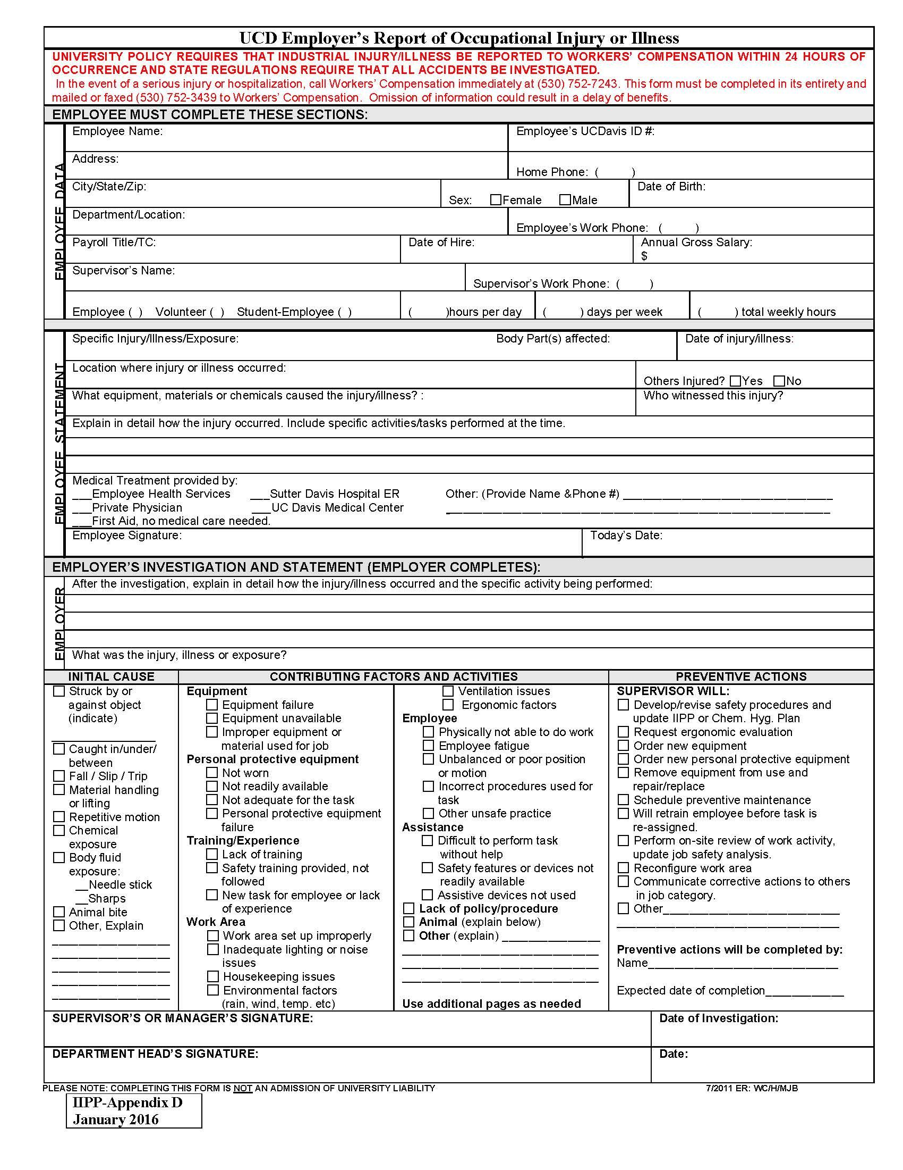

SAFETY TRAINING ATTENDANCE RECORD

Training Topic: |  | Date:
(attach a copy of the training session curriculum)

Instructor: |  | Training Aids:

Location: |  | Time:

Attendees – Please print and sign your name legibly. Use additional sheets if necessary.

No. | Print Name |  | Signature/Date
1.
2.
3.
4.
5.
6.
7.
8.
9.
10.
11.
12.
13.
14.
15.
16.
17.
18.
19.
20.
21.
21.
22.
23.
24.
25.
26.
27.
28.
29.
30.

IIPP-Appendix E | Completed copies of this form should be routed to the department Safety Coordinator
January 2016 | and must be maintained in department files for at least three years.

This page left intentionally blank

