

Human Ecology: Human Development & Community and Regional Development – Hart Hall

Emergency Action and Evacuation Plan

**In compliance with:**

California Code of Regulations

Title 8, Section 3220

Implementation Date: October 2018

|  |  |  |  |  |  |  |
| --- | --- | --- | --- | --- | --- | --- |
| Annual Review Date*: |  |  |  |  |  |  |
|  |  |  |  |  |  |  |
|  |  |  |  |  |  |  |
|  |  |  |  |  |  |  |

*Reviewed and initialed by Department Safety Coordinator

**Introduction**

An Emergency Action & Evacuation Plan (herein referred to as an EAP) covers designated actions employers and employees must take to ensure employee safety from emergencies. [Cal-OSHA regulations](https://www.dir.ca.gov/title8/3220.html) require employers to establish, implement and maintain an EAP. The program must be in writing and include the following elements:

* The preferred means of reporting fires and other emergencies
* A system to alert and notify employees of an emergency
* Evacuation procedures and emergency escape routes
* Procedures for employees who remain to operate critical plant operations before they evacuate
* A procedure to account for all employees after an emergency evacuation is completed
* Rescue and medical duties for those employees who are able to perform them
* Names or regular job titles of persons or departments who can be contacted for further information or explanation of duties under the plan

**How to Complete This Plan Successfully:**

This document includes a template for creating a departmental EAP, as well as additional incident and emergency response training that should be incorporated into the annual training for the EAP. As you read through the document, click on the gray shaded areas and type in the information requested.

*Example:* Department of Human Ecology

This template was designed to help the Department Safety Coordinator (herein referred to as “DSC”) create an EAP, with the understanding that not all departments will have the same structure or protocols during an emergency. As the creator of your department’s plan, you have the flexibility to adjust it to fit your needs to best assure the safety of your colleagues in an emergency.

EAPs are often lengthy documents filled with explanations of the intended actions of every conceivable building occupant. When an event actually occurs, such plans are seldom used efficiently for three reasons: 1) people lack knowledge of the plan, 2) people do not understand the plan, or 3) the plan fails to address the varied physical locations where it must work.

In order for your EAP to be successful, there are essential elements that need to be implemented. These essential elements are detailed on page 8, *Responsibilities of the* *Department Safety Coordinators.*

If you have questions or suggestions regarding this document, please direct those to:

Brent Wagstaff bwagstaff@ucdavis.edu

**Contact Information**

**This EAP has been prepared for UC Davis Department of Human Ecology. The plan complies with California Code of Regulations, Title 8, Section 3220.**

|  |  |
| --- | --- |
| Department of Human Ecology – Human Development & Family Studies Unit and  Community & Regional Development Unit | |
|  | |
| Cynthia Crestmore in 2323 Hart Hall, Business Services Office in 1309 Hart Hall | |
|  | |
| 530-753-5236 or 530-752-8916 | cacrestmore@ucdavis.edu |
|  |  |

|  |  |  |  |  |
| --- | --- | --- | --- | --- |
| William Lacy, HE Department Chair  Elle Barnes, CAO  Zhe Chen, Vice Chair HD  Jonathan London, Vice Chair CRD |  | 530-752-6964  530-752-1127  530-754-6750  530-219-9082 |  | [wblacy@ucdavis.edu](mailto:wblacy@ucdavis.edu)  ebarnes@ucdavis.edu  [zhechen@ucdavis.edu](mailto:zhechen@ucdavis.edu)  jklondon@ucdavis.edu |
| *(Director/Dean/Chairperson)* |  | *(Phone)* |  | *(email)* |

|  |  |  |  |  |
| --- | --- | --- | --- | --- |
| Cynthia Crestmore |  | 530-752-5236 |  | cacrestmore@ucdavis.edu |
| *(Department Safety Coordinator)* |  | *(Phone)* |  | *(email)* |

|  |  |  |  |  |  |  |
| --- | --- | --- | --- | --- | --- | --- |
| Alternate contact Chris Collier, Systems Analyst |  | 530-752-2784 | |  | ccollier@ucdavis.edu | |
|  |  |  | |  |  | |
| **This Emergency Action & Evacuation Plan will be reviewed annually in:** | | | | **October** | | |

**Protocols-Alert and Notification**

**Reporting Emergencies:**

In the event of an emergency, UC Davis employees should contact UC Davis Dispatch by dialing **9-1-1** from a land line or a cell phone.

**You should call 9-1-1:**

* In the event of a medical emergency
* To report all fire incidents, ***even if the fire is extinguished***

*You should immediately alert the UC Davis Fire Department of any extinguisher usage.*

* To report criminal or suspicious behavior
* If you are in doubt about the seriousness of a situation, such as any possible situation that you believe may be serious and that may result in injury, death, loss of property, apprehension of a suspected criminal or prevention of a crime that is about to occur.

**Provide the following information to UC Davis Dispatch upon calling**

* Who you are
* Whether you are in a safe location
* What the nature of the emergency is
* Where it is located
* When it happened
* How it happened

**Alert and Notification of Employees:**

If an emergency calls for an evacuation or employees to take action, there needs to be a system in place to notify them. Emergency alert and notification of employees should be multi-layered, as systems can fail. A variety of methods are available, though not all systems apply to every building on the UC Davis campus, including:

* Audible alarm

*Examples of notification methods include: fire alarm system, PA system, phone tree, bullhorn, even just flashing the lights can be a way to let people know there is an emergency happening.*

* Visual alarms/signals
* Verbal notification
* UC Davis WarnMe
* Via other electronic media

**The methods of alert & notification of employees in this department are:** Primary Method - Alarm System. Additional notifications - Verbal Notification; UC Davis Warn Me; Email; Instant Messaging; Texting; Phone. If bomb threat, use signal to alert other staff to call 911; send IM to lead staff in Business Unit.

**Emergency Protocols-Evacuation**

**Evacuation Procedures & Routes**

Many incidents (*e.g.* building fire, police response) could require an evacuation of all or part of the campus. All employees must evacuate the building when notified to do so. The type of evacuation or protective measure may be specified as part of the notification. Please refer to Policy & Procedure [390-10](http://manuals.ucdavis.edu/PPM/390/390-10.pdf) for more information on Campus Emergency Policy.

***Evacuation Types***

* **Evacuation:** Evacuation is total building or partial building evacuation due to conditions making it no longer safe to remain inside a building or a specific area in a building. This level of evacuation requires occupants to move out and away from the building being evacuated.
* **Controlled Evacuation:** Controlled evacuation is total building or partial building evacuation due to safety conditions or an armed intruder making it no longer safe to remain inside a building or specific area in a building. This level of evacuation requires occupants to move out and away from the building once notified.
* **Shelter-in-Place:** Shelter-in-place means selecting a small interior room, with no or few windows, and taking refuge there; it does not mean sealing off your entire office. Shelter-in-place is used in emergency situations where hazardous materials have been released into the atmosphere or in emergencies related to civil unrest or violent demonstrations.
* **Lock Down:** Lockdown is the temporary sheltering technique utilized to limit exposure to an “armed intruder” or similar incident. When alerted, occupants of a building within the area of concern will lock all doors and windows, not allowing entry or exit to anyone until the all clear has been sounded. If you are in a ground floor office or common area, take precautions and move away from glass windows or doors and seek shelter in a locked room of office.

***Prior to Exiting***

After being notified to evacuate, stop all work activities and evacuate immediately. Securely close departmental and office doors behind you. You may choose to lock your doors to prevent property theft (the UC Davis Fire Department has keys to campus buildings and rooms if access is necessary). Remember that you may not be allowed back into the building for an extended time.

***Evacuation Routes/Exiting the Building***

During an emergency evacuation, use the nearest door or stairway if available. Each employee needs to be aware of at least two exit routes in their main building in the event one is compromised.

All campus buildings over one story high must have building evacuation signs posted on every floor. The signs must be posted at all stairway and elevator landings and immediately inside all public entrances to the buildings. More information on this is available in the FireNet [Emergency Evacuation Signs](http://safetyservices.ucdavis.edu/ps/fp/fn/ee/emergencyEvacuationSigns.pdf/view).

Persons involved with developing the EAP need to address how to evacuate colleagues with special needs that are unable to evacuate on their own. More information and guidance on this topic can be found in the FireNet [Guidelines to Emergency Evacuation Procedures for Employees/Clients with Disabilities](http://safetyservices.ucdavis.edu/ps/fp/fn/ee/emergencyEvacuationOfDisabled.pdf/view).

***Assembly Area***

[*Assembly Area Guidelines*](http://safetyservices.ucdavis.edu/ps/ecp/ep/EAP/assemblyAreaGuidelines) *have been developed to help DSCs choose the safest location to assemble.*

After exiting the building, all employees, students, volunteers, and visitors should follow the evacuation route to the pre-arranged assembly area.

The Department Chair should assign an Assembly Area Manager to each evacuation location. List all buildings in which department members are assigned space and the corresponding assembly areas and manager.

**Southwest corner of the Quad opposite Hart Hall.** Report to either Elle Barnes, William Lacy, Zhe Chen, Jonathan London, or Cynthia Crestmore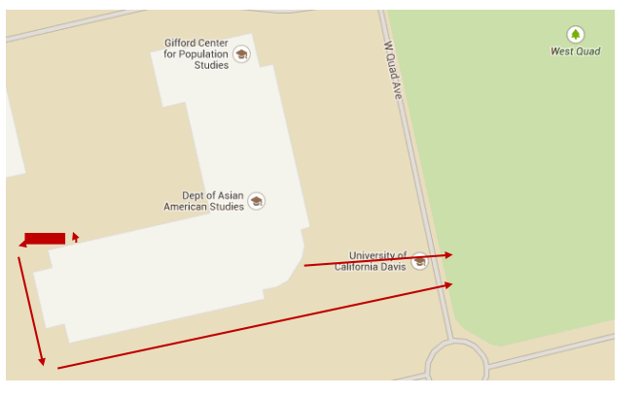

All employees should stay within your respective group at the Assembly Area. No one should leave the area until notified by the First Responders, Assembly Area Manager, or Responder Liaison.

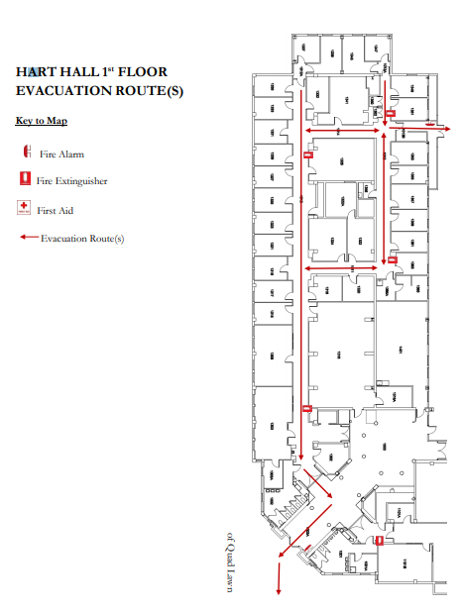

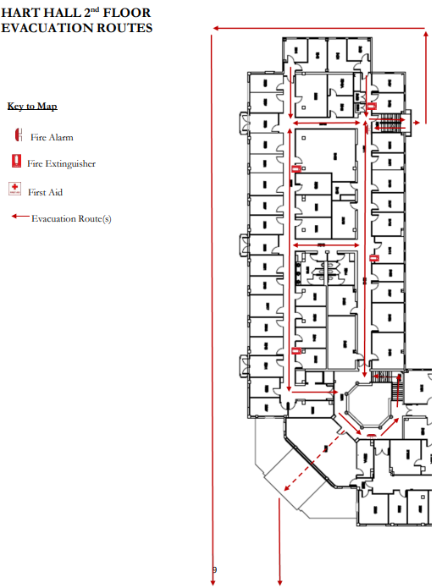

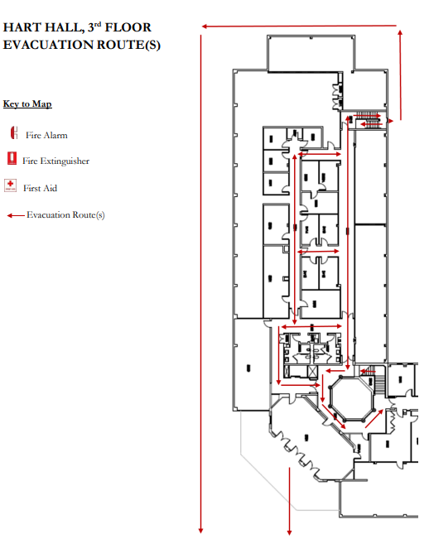

**Assigned Job Responsibilities**

***Assembly Area Manager Duties:***

It is recommended that the senior employee or their designee acts as the Assembly Area Manager. The Assembly Area Manager should be responsible for taking roll call and therefore it is imperative that *prior* to an emergency the Department Safety Coordinator (DSC) and Assembly Area Manager work together to ensure an updated employee roll call sheet is available and accessible at the time of the emergency. Ideally, the person responsible for roll call will take a personnel list (use attached form or alternate) before leaving the building. The Assembly Area Manager should report any injuries in need of immediate care to First Responders. Any other minor injuries should be documented and reported through the proper chain of command to Elle Barnes, CAO of Cluster 5.

The Assembly Area Manager is responsible for sharing information as it becomes available to the evacuated persons. The Assembly Area Manager *should not leave* the assembly area; therefore it is suggested the Assembly Area Manager assign a liaison to the First Responders.

***Responder Liaison Duties:***

The Responder Liaison ensures important communication and information exchange between the First and Second Responders (*e.g.* Fire, Police, Facilities), and the Area Assembly Manager. The Responder Liaison (whom may be the DSC if present) is responsible for informing the on-scene Incident Commander of the status of department employees and visitors. Responder Liaisons should be prepared to provide the following information (if known)

* Nature of the emergency (*e.g.* fire)

*If needed, the Responder Liaison should recruit volunteers to help direct and contain evacuees to the Assembly Area.*

* Location of the emergency
* Number of persons trapped
* Number of persons hurt
* Number of persons unaccounted for

After a major incident, building occupants may not re-enter buildings until cleared by a campus official.

**Procedures for Employees Who Remain to Operate Critical Operations**

Safety is a top priority at UC Davis, and there are no critical operations worth risking one’s welfare to perform. If you believe your department has critical operations requiring an employee(s) to remain in the building during an evacuation (most departments will not), please contact [Brent Wagstaff](mailto:bwagstaff@ucdavis.edu) to develop this section of the plan.

**Rescue & Medical Duties**

UC Davis relies on the UC Davis Fire Department and partnering agencies to provide rescue and medical duties. It may be useful to document employees in your department who have specialized medical training.

**None identified**

*The individuals listed above should not practice outside their scope of training and are not expected or required to assist in any emergency or medical situation.*

**Responsibilities of the Department Safety Coordinator**

Elle Barnes, CAO and Department Chair William Lacy are responsible for implementing essential elements including planning, evaluating, and implementing the EAP. The following duties must be performed to maintain an effective EAP:

* Review and update the EAP annually or as needed.
* Update and submit the [Emergency Call List](http://police.ucdavis.edu/pdf/Emergency_Call_List_2-6-07.pdf) to the [UC Davis Dispatch Center](mailto:letgarcia@ucdavis.edu).
* Train employees on the location of emergency exits, fire extinguishers, manual pull stations, first aid kits, and AEDs if applicable.
* Ensure evacuation routes are posted and walkways remain clear at all times.
* Train employees annually on the EAP, including the “Additional Training”sections. Ensure all new hires are familiar with the procedures and a copy of the plan is made available. **Document all training.**
* Train the Assembly Area Managers, Responder Liaisons, and Alternate Department Safety Contact. Confirm they understand their duties as assigned in the plan.
* Exercise your department’s EAP annually. It is recommended you exercise your plan in the following order:
  1. **Conduct a Tabletop Exercise.** This will allow departments to use their training on the EAP, as well as to work through any inefficiencies *prior* to an emergency. Contact [Brent Wagstaff](mailto:bwagstaff@ucdavis.edu) for training or assistance with your tabletop exercise.
  2. **Schedule a Building Evacuation.** The UC Davis Fire Department can perform a limited number of building evacuations each month. Advanced notice and coordination between the departments that share your building **before** the exercise is critical. The Fire Department **will not** conduct the exercise if coordination between department DSCs has not occurred.Please contact your [Department Safety Coordinator](http://safetyapps.ucdavis.edu/EHS/dsc/index.cfm) to schedule an exercise. Evacuations will be scheduled on a first come first serve basis and times and dates will be decided based on the Fire Department’s availability. To schedule a fire drill, please contact the [UC Davis Fire Department](http://fire.ucdavis.edu/wyn/request_a_fire_drill).

**Add *signed* Signature page here**

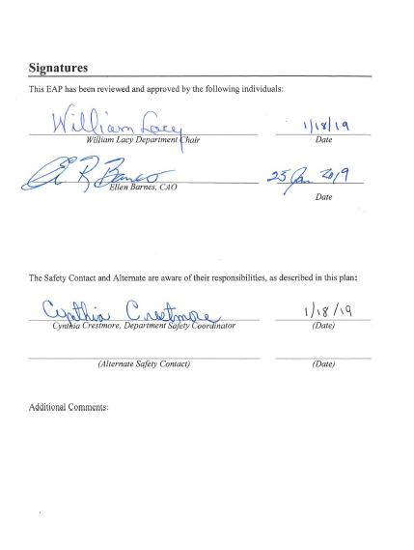

**Communications for Campus-Wide Emergencies**

In the event of a major emergency, there are multiple ways to distribute life-saving and other important information. Familiarize the individuals in your department with these communication methods:

* **Check the University homepage** [www.ucdavis.edu](http://www.ucdavis.edu)

UC Davis posts information about emergencies and other major news on its home page at [www.ucdavis.edu](http://www.ucdavis.edu)**.** News can also be found at [www.news.ucdavis.edu](http://www.news.ucdavis.edu) or <http://www.ucdavis.edu/emergency/emergency-services.html>

* **Call the Emergency Status Line (530) 752-4000**

The Emergency Status Line provides a recorded telephone message about the status of the Davis campus in an emergency. It indicates the emergency’s nature and provides brief instructions.

* **Listen to the News Media**

UC Davis works with the news media to share information about emergencies and provide direction to the university community.

AM radio KFBK 1530 initiates public Emergency Alert System messages for several area counties. The station offers live audio streaming at [www.kfbk.com](http://www.kfbk.com)

* **Become a “Fan” on Facebook**

UC Davis sends emergency bulletins to its “fans” on Facebook. If you aren’t already a member, join Facebook at www.facebook.com***.*** Then you will be able to visit UC Davis’ Facebook site and click through to become a fan.

* **Sign up for Personal Alerts through the WarnMe system**

This emergency notification service provides students and employees with timely information and instructions during emergencies. UC Davis WarnMe sends alerts by e-mail, telephone, cell phone and text messaging. To deliver messages, WarnMe uses employees’ work contact information from the university’s online directory, students’ e-mail addresses and personal contact information you voluntarily provide. Register and update your information at <http://warnme.ucdavis.edu>.

*It is important to understand that you will not be notified of every incident that UC Davis Police or Fire responds to. In a campus-wide emergency, communications may be sent out one or all of the ways listed above and will vary depending on the incident.*

Sheltering-in-Place

One of the instructions you may be given in an emergency is to shelter-in-place. Shelter-in-place is used mainly for hazardous materials incidents and sustained police action, or when it is more dangerous to venture outside than to remain indoors in your current location. This means you should remain indoors until authorities tell you it is safe or you are told to evacuate. The following are guidelines that should be shared with your department’s employees.

General Guidelines on how to Shelter-in-Place

* Select a small, interior room, with no or few windows, ideally with a hard-wired telephone (cellular telephone equipment may be overwhelmed or damaged during an emergency).
* Close and lock all windows and exterior doors.
* Review your EAP, inspect your workplace emergency kits if you have them.
* Do not exit the building until instructed to do so by campus officials.
* Check for status updates using the resources detailed in the section, “Communications for Campus Wide Emergencies."

Specific for a Hazardous Material Incident

* Turn off all fans, heating and air conditioning systems
* If instructed, use duct tape and plastic sheeting (heavier than food wrap) to seal all cracks around the door and any vents into the room
* If you are in your car, close windows and turn off vents and air conditioning

*In an incident requiring you to shelter-in-place, it may take several hours before it is safe to leave your building. It is important to have food and water in your office or work location to last a minimum of 24 hours, and preferably up to 72 hours. Having a workplace preparedness kit is easy to make and a good idea.*

**In the Event of an Earthquake**

• Take cover under a desk or table, or in a doorway or corner. Stay away from windows, display cases and outside walls. If you are in a crowded public area DO NOT RUSH for doorways!

• After the shock subsides, do not evacuate unless instructed to do so. If the decision is made to evacuate, follow the instructions given earlier in this plan. Stay clear of buildings and trees.

• Notify the Fire/Police Communications Center at 9-1-1 if there are serious injuries or hazards. • Notify the Facilities Service Call Center (530-752-1655) if there are water leaks, the smell of gas or smoke, flooding, or any other damage that requires immediate attention – DO NOT ENTER flooded areas.

• Stay away from area where aftershocks could dislodge loose debris.

•If the earthquake was small and/or it has been determined it caused no serious damage, you may resume normal activities.

In the Event of an Active Shooter

If it is safe to do so:

• RUN! Otherwise,

• Shut and lock your office door

• Turn off lights

• Seek cover and/or get down as low and out of sight as possible

• Do not come out until emergency personnel tell you it is safe to do so.

The UC Davis Police Department hosts workshops to the members of the campus community presenting strategies to increase the likelihood of surviving an active shooter. The workshop covers five steps for increasing your chances of surviving an active shooter and also provides demonstrations for attacking the attacker.

Presentations run approximately 90 minutes including a question/answer session, but it is recommended departments allow 2 hours release time for employees, as there is a hands-on component at the end of the presentation. Community presentations are available on the Davis and Sacramento campuses throughout the year. To schedule a workshop please contact:

UCDPD Outreach Unit

Ray Holguin

(530) 752-1727

[rholguin@ucdavis.edu](mailto:rholguin@ucdavis.edu)

In the training, *Community Survival Strategies for an Active Shooter* participants should be aware that the presentation deals with a very sensitive subject and uses actual audio tape from the 9-1-1 call at the Columbine shootings. Participants will also have the opportunity to see different types of firearms and should be prepared to hear what an actual gunshot sounds like.

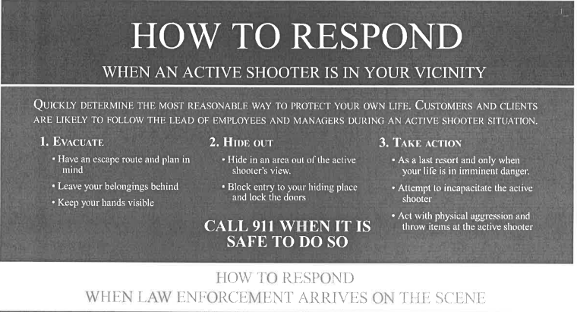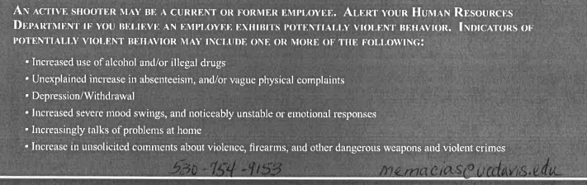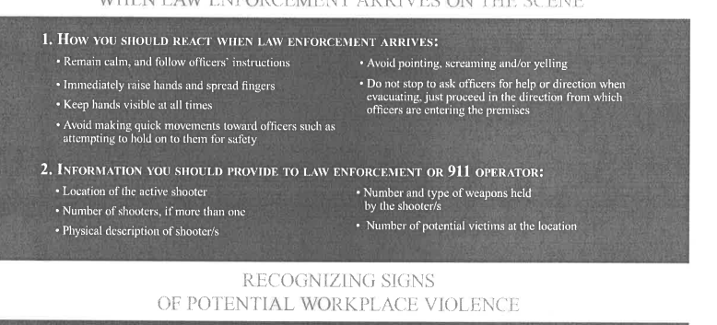



At the first sign of fire or smoke:

• Close the door to the room where the fire is located but DO NOT lock it.

• Notify the Fire Department either by sounding the building alarm or by calling the Fire/Police Communications Center at 9-1-1. NOTE: The pull alarms will work even if the electricity is out.

• If you sound the building alarm, follow through with a call to 9-1-1 to provide additional information.

• Do not hang up until the dispatcher instructs you to do so.

• Notify Elle Barnes, CAO, Bill Lacy, Chair, or Cynthia Crestmore, Safety Coordinator

If the fire is small (i.e. confided to a wastebasket, etc.) it may be possible to fight the fire with a fire extinguisher or fire hose. However, if the fire is large, smoky or spreading rapidly, default on the side of safety and follow the instructions below. Evacuate if the building alarm sounds or if the department is notified by a safety coordinator to evacuate.

If time permits and it is safe to do so-

• Turn off your computer and monitor

• Collect your valuables and keys

• Leave lights on

• Close windows

• Close doors but leave then unlocked

Follow directions, if any, given by the safety coordinator

• Walk to the nearest exit or to an alternate exit if the designated one is not safe.

• DO NOT USE THE ELEVATOR!

• After exiting the building proceed to the arranged Assembly Area at the SIDEWALK ON EAST SIDE OF MU BUILDING JUST NORTH OF THE EAST ENTRANCE (refer to the Evacuation Maps on the previous pages). Remain at least 100 feet away from buildings or farther, if so directed by emergency personnel.

Report to Elle Barnes, CAO, Bill Lacy, Chair, or Cynthia Crestmore, Safety Coordinator to let them know you are safe. If you become aware of others who were in the building but do not now see in the roll call area, inform the CAO or safety coordinator.

Do not leave the area or reenter the building until instruction it is safe to do so by the CAO, safety coordinator or emergency personnel.

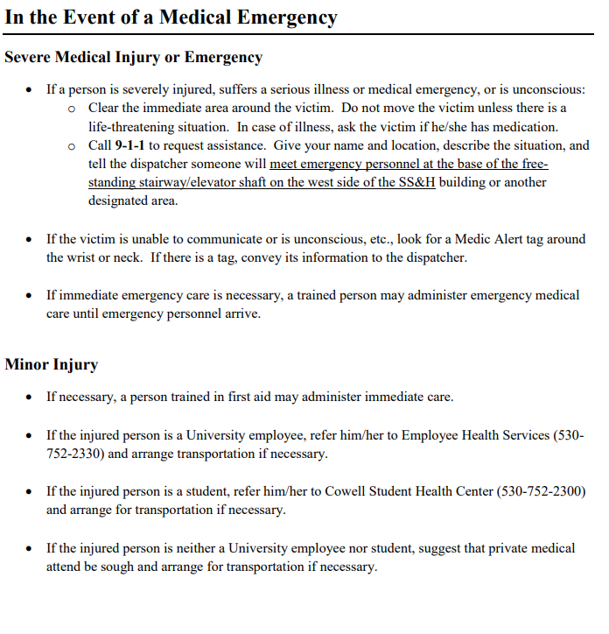

**Severe Medical Injury or Emergency**

• If a person is severely injured, suffers a serious illness or medical emergency, or is unconscious:

o Clear the immediate area around the victim. Do not move the victim unless there is a life-threatening situation. In case of illness, ask the victim if he/she has medication.

o Call 9-1-1 to request assistance. Give your name and location, describe the situation, and **tell** the dispatcher someone will meet emergency personnel at the base of the freestanding stairway/elevator shaft on the west side of the SS&H building or another designated area.

• If the victim is unable to communicate or is unconscious, etc., look for a Medic Alert tag around the wrist or neck. If there is a tag, convey its information to the dispatcher.

• If immediate emergency care is necessary, a trained person may administer emergency medical care until emergency personnel arrive.

**Minor Injury**

• If necessary, a person trained in first aid may administer immediate care.

• If the injured person is a University employee, refer him/her to Employee Health Services (530- 752-2330) and arrange transportation if necessary.

• If the injured person is a student, refer him/her to Cowell Student Health Center (530-752-2300) and arrange for transportation if necessary.

• If the injured person is neither a University employee nor student, suggest that private medical attention be sought and arrange for transportation if necessary.

attention be sought and arrange for transportation if necessary.



Do not confront the individual committing the act, or attempt to restrain him/her unless it is for self-protection.

• If it is safe to do so, photograph the person with a smartphone or take the time to get a good description of the person.

o Gender

o Race o

Age (approximate)

o Height (approximate)

o Weight (approximate)

o Type of build

o Color and style of hair

o Clothing

o Distinguishing marks or mannerisms

• If the person is leaving the area, note:

o Direction of travel

o Means of travel

• If the person is leaving by vehicle, note:

o License plate number o Make and model of the vehicle

o Color of the vehicle

Call the Fire/Police Communications Center at 9-1-1. Give them your name and location, describe the situation, and remain where you are until contacted by emergency personnel.

Notify the safety coordinator or CAO so they can inform employees in the department. Anyone who has seen the person should call the UCD Police Department.

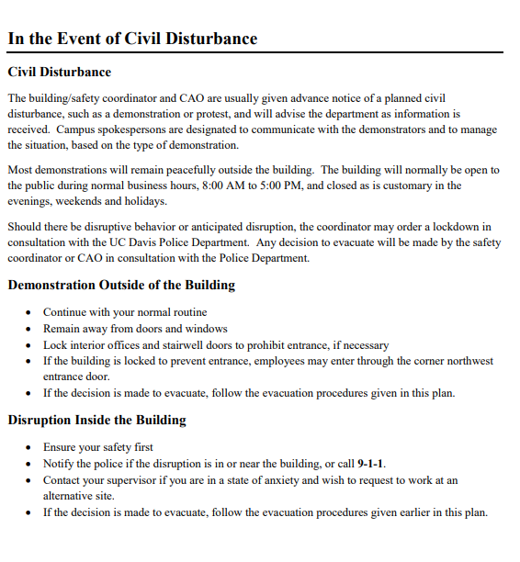

**Civil Disturbance**

The building/safety coordinator and CAO are usually given advance notice of a planned civil disturbance, such as a demonstration or protest, and will advise the department as information is received. Campus spokespersons are designated to communicate with the demonstrators and to manage the situation, based on the type of demonstration.

Most demonstrations will remain peacefully outside the building. The building will normally be open to the public during normal business hours, 8:00 AM to 5:00 PM, and closed as is customary in the evenings, weekends and holidays.

Should there be disruptive behavior or anticipated disruption, the coordinator may order a lockdown in consultation with the UC Davis Police Department. Any decision to evacuate will be made by the safety coordinator or CAO in consultation with the Police Department.

**Demonstration Outside of the Building**

• Continue with your normal routine

• Remain away from doors and windows

• Lock interior offices and stairwell doors to prohibit entrance, if necessary

• If the building is locked to prevent entrance, employees may enter through the corner northwest entrance door.

• If the decision is made to evacuate, follow the evacuation procedures given in this plan.

**Disruption Inside the Building**

• Ensure your safety first

• Notify the police if the disruption is in or near the building, or call 9-1-1.

• Contact your supervisor if you are in a state of anxiety and wish to request to work at an alternative site.

• If the decision is made to evacuate, follow the evacuation procedures given earlier in this plan.

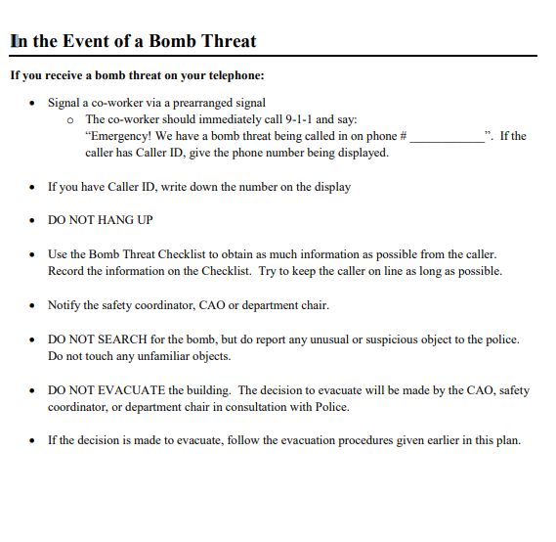

**If you receive a bomb threat on your telephone:**

• Signal a co-worker via a prearranged signal

o The co-worker should immediately call 9-1-1 and say: “Emergency! We have a bomb threat being called in on phone # ____________”. If the caller has Caller ID, give the phone number being displayed.

• If you have Caller ID, write down the number on the display

• DO NOT HANG UP

• Use the Bomb Threat Checklist to obtain as much information as possible from the caller. Record the information on the Checklist. Try to keep the caller on line as long as possible.

• Notify the safety coordinator, CAO or department chair.

• DO NOT SEARCH for the bomb, but do report any unusual or suspicious object to the police. Do not touch any unfamiliar objects.

• DO NOT EVACUATE the building. The decision to evacuate will be made by the CAO, safety coordinator, or department chair in consultation with Police.

• If the decision is made to evacuate, follow the evacuation procedures given earlier in this plan.

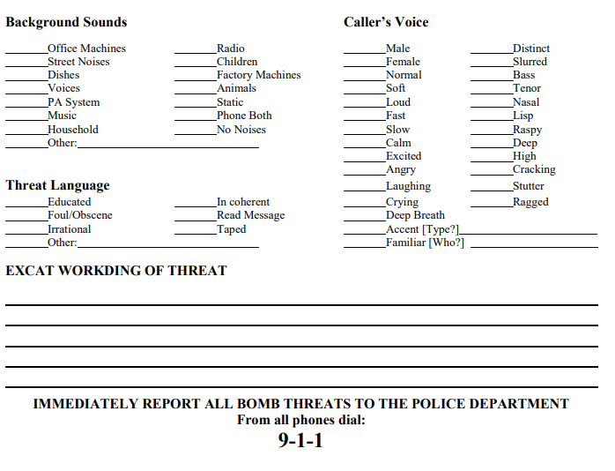

**EXACT WORDING OF THREAT**







**IMMEDIATELY REPORT ALL BOMB THREATS TO THE POLICE DEPARTMENT**

**From all phones dial: 9-1-1**

**Questions to ask the Caller:**

When is the bomb going to explode?

Where is it right now? What does it look like?

Did you place the bomb? 

Why? 

What is your address? 

What is your name? 

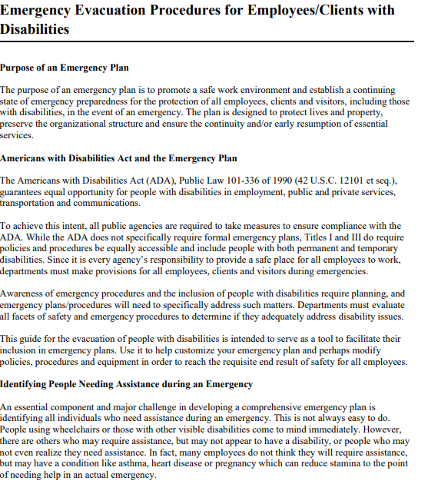

**Purpose of an Emergency Plan**

The purpose of an emergency plan is to promote a safe work environment and establish a continuing state of emergency preparedness for the protection of all employees, clients and visitors, including those with disabilities, in the event of an emergency. The plan is designed to protect lives and property, preserve the organizational structure and ensure the continuity and/or early resumption of essential services.

**Americans with Disabilities Act and the Emergency Plan**

The Americans with Disabilities Act (ADA), Public Law 101-336 of 1990 (42 U.S.C. 12101 et seq.), guarantees equal opportunity for people with disabilities in employment, public and private services, transportation and communications.

To achieve this intent, all public agencies are required to take measures to ensure compliance with the ADA. While the ADA does not specifically require formal emergency plans, Titles I and III do require policies and procedures be equally accessible and include people with both permanent and temporary disabilities. Since it is every agency’s responsibility to provide a safe place for all employees to work, departments must make provisions for all employees, clients and visitors during emergencies.

Awareness of emergency procedures and the inclusion of people with disabilities require planning, and emergency plans/procedures will need to specifically address such matters. Departments must evaluate all facets of safety and emergency procedures to determine if they adequately address disability issues.

This guide for the evacuation of people with disabilities is intended to serve as a tool to facilitate their inclusion in emergency plans. Use it to help customize your emergency plan and perhaps modify policies, procedures and equipment in order to reach the requisite end result of safety for all employees.

Identifying People Needing Assistance during an Emergency An essential component and major challenge in developing a comprehensive emergency plan is identifying all individuals who need assistance during an emergency. This is not always easy to do. People using wheelchairs or those with other visible disabilities come to mind immediately. However, there are others who may require assistance, but may not appear to have a disability, or people who may not even realize they need assistance.

In fact, many employees do not think they will require assistance, but may have a condition like asthma, heart disease or pregnancy which can reduce stamina to the point of needing help in an actual emergency.

A sample memo and form that can be used to help identify employees who need assistance follow this section. It is important to protect the confidentiality of this information. Some employees fear it will be used against them and are reluctant to come forward and ask for assistance. To accurately identify all employees who need assistance, it is especially important to address these fears. All information must be kept confidential according to the Federal Privacy Act (P.L. 93-579) and the Information Practices Act of 1977 (Civil Code Sections 1798, et seq.).

**Identifying Employees with Disabilities**

• Prepare a memo to all employees with an attached form requesting information regarding assistance that may be needed during an emergency. (See examples located after this section.)

• To survey new employees, include the memo and form in the new employee paperwork

• Review forms of employees requesting assistance and the type of assistance requested.

• Contact each person who is requesting assistance and discuss the best way to provide support. It is important to consider the individual’s personal preferences, privacy and dignity when discussing assistance. If an aide is requested, ensure a person with a disability has the option of asking the department to solicit volunteers and allowing the person to choose from the volunteers or personally select the aide(s).

• Develop a list of people who are willing to assist others with disabilities during emergencies. • Make sure there are at least 2 emergency aides for each person. Contact requested aides to ask if they are willing to accept the responsibility.

• Meet with the person requesting assistance and the emergency aides to discuss procedures and training.

o The department and the person requesting assistance should conduct training for the aides as soon as they are recruited. The person requesting assistance will address his/her individual needs. Some people with disabilities who have requested emergency aides will not want to be evacuated during drills and minor emergencies.

• Follow your office’s procurement policy and procedures to obtain emergency equipment as needed. Make sure people requesting assistance and the emergency aides know how to use the equipment.

• Designate an area of refuge on each floor. This is a safe area with direct access to an exit. People who are unable to use the stairs may remain there temporarily while awaiting further instructions or assistance during an emergency evacuation. The Fire Prevention staff will determine the location(s) of the area of refuge. Include the areas of refuge on the evacuation route maps posted on each floor.

• Contact the person in charge of your department to inform them of people who have requested assistance.

• Maintain a list of people who have requested emergency aides, the type of assistance needed and the designated emergency aides, if applicable.

• Contact people requesting assistance to make sure training is complete and equipment, if necessary, has been received and is ready for use.

• Conduct an “Emergency Evacuation Information” survey annually.

**Sample Memo**

**Date**:

**To**: All Employees

**From**:

**Subject: Identifying Employees Needing Assistance During an Emergency**

Currently, our Department is in the process of reviewing and updating our Emergency Plan. An essential component in a comprehensive plan is identifying all employees who may need assistance during an emergency. The need for assistance may be permanent or temporary such as when you are recovering from surgery or a broken leg. When completing this form, evaluate your situation thoroughly and honestly. You might not think you need assistance, but a heart condition, asthma or pregnancy can reduce your stamina to the point where you need assistance during an emergency. In addition, a hearing loss might limit your ability to respond to an audio alarm or evacuation information.

Describe in detail the type of assistance you think you will need**. It is not necessary to give medical details.**

If you want colleagues to assist you, you can either select your own or choose from a list of volunteers the department has on file. If you choose your own, list their names and phone numbers. You should select a primary aide and a back-up as well. Make sure you select “emergency aides” who can handle their assigned tasks.

Please complete the attached form and return it to the Emergency Coordinator ----------------------, in Room --------------. The Coordinator will contact you to discuss your request.

This information will be kept confidential according to the Federal Privacy Act (P.L. 93-579) and the Information Practices Act of 1977 (Civil Code Sections 1798, et seq.). Ti will be used only to provide assistance during an emergency.

It is our goal to safely and efficiently protect every employee, client and visitor during an emergency and to preserve everyone’s personal dignity in the process. It is our responsibility to provide a safe place for you to work. However, we cannot be held liable for your safety if you do not identify your need for assistance.

Thank you,

Signature

Attachment

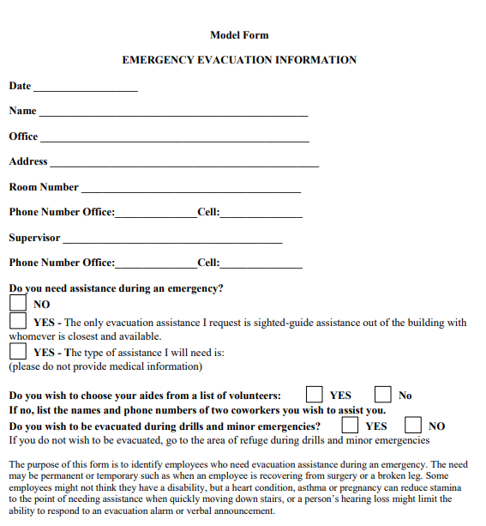

The purpose of this form is to identify employees who need evacuation assistance during an emergency. The need may be permanent or temporary such as when an employee is recovering from surgery or a broken leg. Some employees might not think they have a disability, but a heart condition, asthma or pregnancy can reduce stamina to the point of needing assistance when quickly moving down stairs, or a person’s hearing loss might limit the ability to respond to an evacuation alarm or verbal announcement.

The information will be given to the Emergency Coordinator who will contact you to discuss your request and will notify your emergency floor warden. All information will be kept confidential pursuant to the Federal Privacy Act (P.L. 93-579) and the Information Practices Act of 1977 (Civil Code Sections 1798, et seq.). If you have any questions, please contact your emergency coordinator at _____________

Please remember: We are committed to your safety, but need your help in identifying your need for assistance.

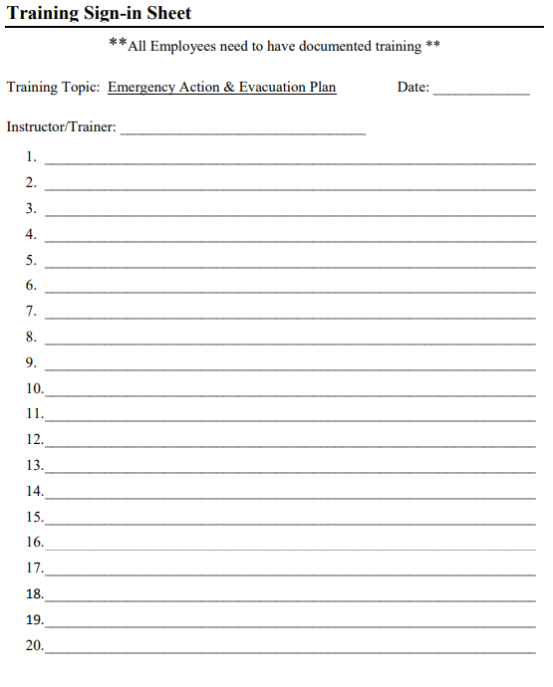

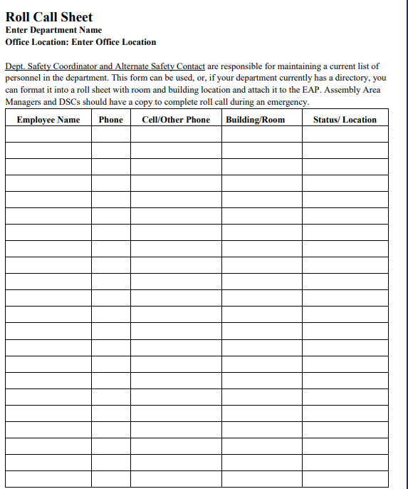

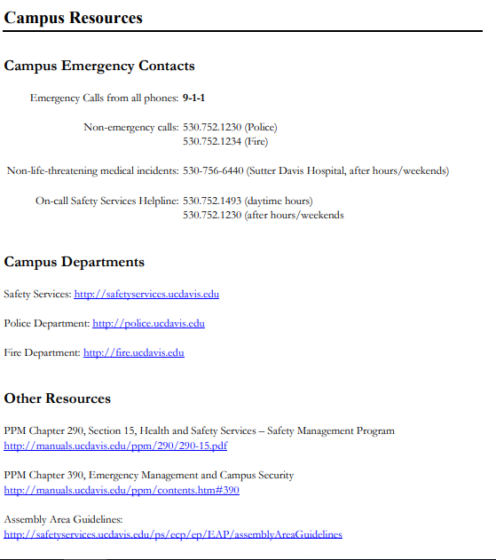

**Campus Emergency Contacts Emergency**

Calls from all phones: 9-1-1

Non-emergency calls: 530.752.1230 (Police)

530.752.1234 (Fire)

Non-life-threatening medical incidents: 530-756-6440 (Sutter Davis Hospital, after hours/weekends)

On-call Safety Services Helpline: 530.752.1493 (daytime hours) 530.752.1230 (after hours/weekends

**Campus Departments**

Safety Services: <http://safetyservices.ucdavis.edu>

Police Department: <http://police.ucdavis.edu>

Fire Department: <http://fire.ucdavis.edu>

**Other Resources**

PPM Chapter 290, Section 15,

Health and Safety Services – Safety Management Program <http://manuals.ucdavis.edu/ppm/290/290-15.pdf>

PPM Chapter 390, Emergency Management and Campus Security <http://manuals.ucdavis.edu/ppm/contents.htm#390>

Assembly Area Guidelines: http://safetyservices.ucdavis.edu/ps/ecp/ep/EAP/assemblyAreaGuidelines